Department of Computer Science and Engineering (Data Science)
CSDS-A | Batch A3 (CSE - Data Science, Section A)
A Dynamic Phishing URL Detection System Integrating Advanced Machine Learning and Crowdsourced Threat Intelligence
(PhishGuard)
S.No. | Student name | Roll / hall ticket no.
1 | D.ANISH MEGHAN | 23K91A6750
2 | B.AKSHAYA | 23K91A6737
3 | B.TANUJA | 23K91A6736
4 | CH.SAI CHETHAN | 23K91A6742
Under the guidance of: Mr. G. Ravi, [DESIGNATION]
SCOPE AND LIMITATIONS
This document states what PhishGuard covers and what it deliberately does not, the assumptions behind the design, and the honest limitations of the system and of the evidence for it.

1 Scope of the Project

1.1 In scope
- Classification of a single URL or a pasted or uploaded batch of up to 100 URLs, in real time.
- 47 offline URL features in three groups, with a plain-language list of red flags.
- Comparison of three classifiers on one 40,000-URL dataset with a fixed 80/20 split, plus 5-fold cross-validation.
- A SQLite store of community reports with vote counting, consensus, and optional import from two public feeds.
- Retraining from confirmed reports, with automatic reload of the new model.
- A React web interface (seven pages) over a Flask JSON API, a command-line interface, and the original Flask pages.

1.2 Out of scope
- Downloading or rendering the page behind a URL, and any WHOIS, DNS or certificate lookup.
- E-mail, SMS or attachment analysis, and image or logo comparison of the page.
- User accounts, authentication, moderation workflows and administrator verification of reports.
- Browser extensions, mail-gateway plug-ins and deployment at internet scale.
- Deep-learning models; the base paper's LSTM network is not reproduced.

2 System Boundary
The two diagrams below show the boundary of PhishGuard: what flows across it (context diagram) and who may do what inside it (use-case diagram).
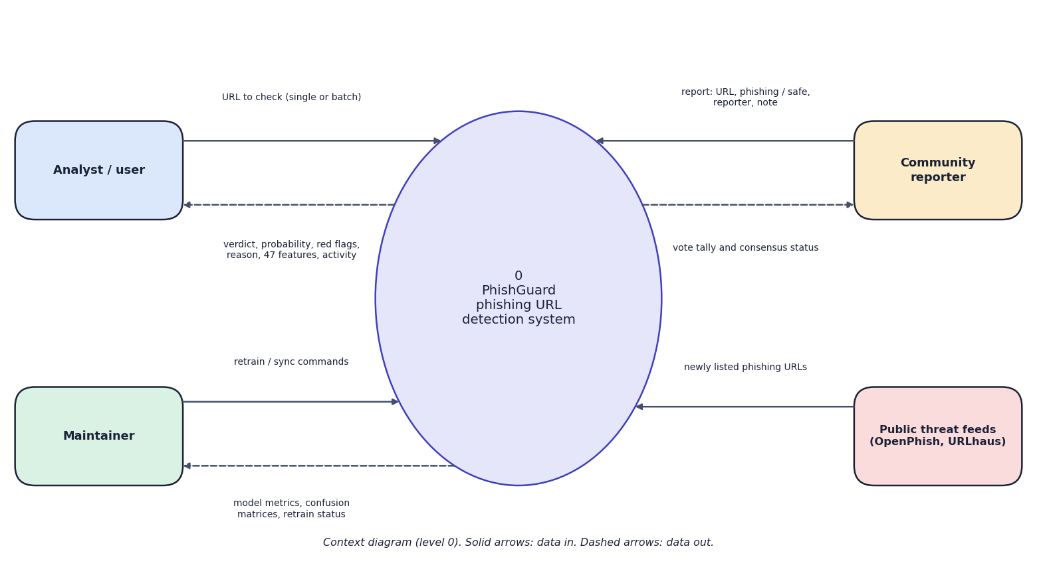
Fig. 1: Data-flow diagram, level 0 (context)
The context diagram shows PhishGuard as one process and four external entities. The analyst sends URLs and receives verdicts, probabilities, red flags and the activity log. The community reporter sends reports (URL, phishing or safe, reporter, note) and receives the vote tally and status. The maintainer sends retrain and sync commands and receives metrics and retrain status. The public threat feeds supply newly listed phishing URLs. The analyst and the reporter are often the same person; they are drawn separately because they use different pages.
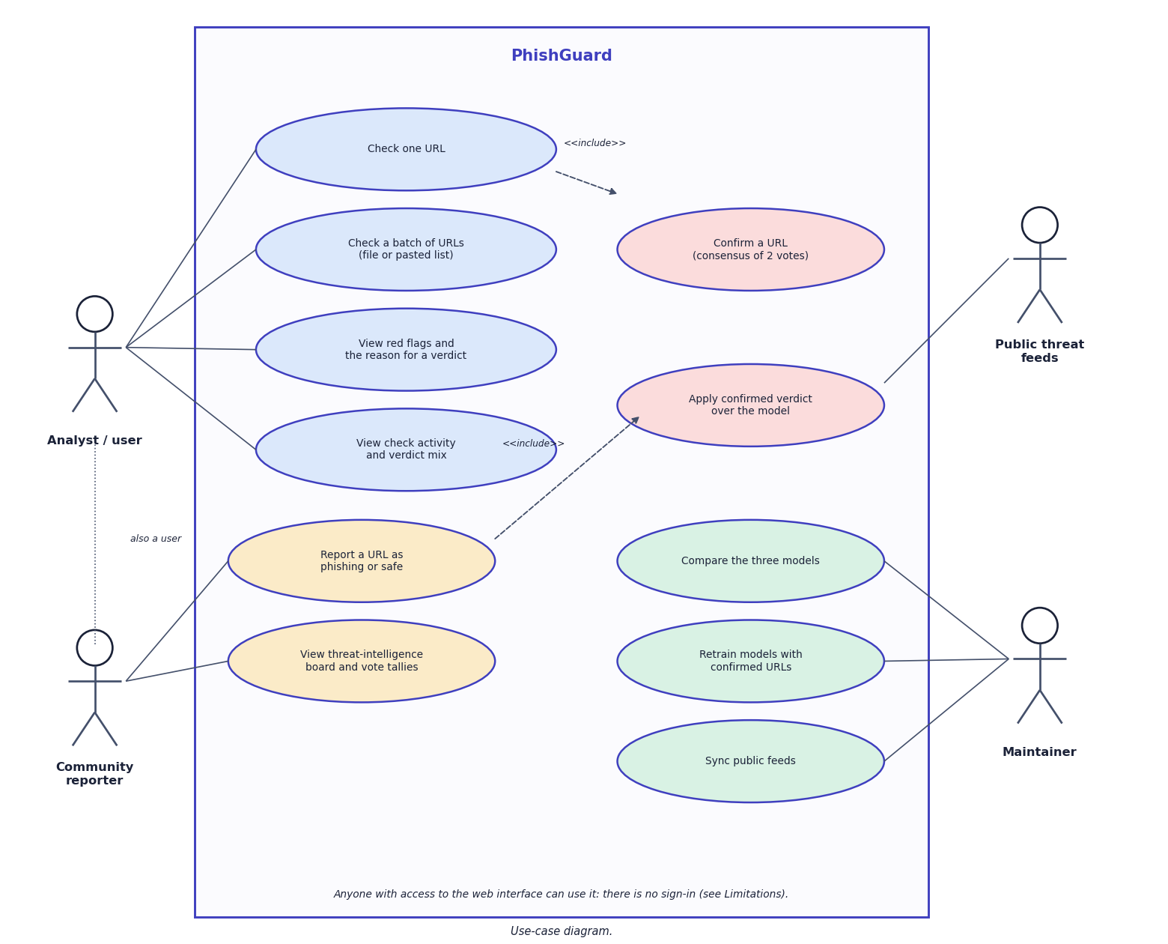
Fig. 2: Use-case diagram
The use-case diagram has four actors. The analyst checks a URL or a batch, reads the red flags and the reason, and reviews the activity log. The community reporter reports a URL and views the threat-intelligence board; reporting includes confirmation by consensus. Checking a URL includes applying a confirmed verdict over the model. The maintainer compares the models, retrains them and synchronises the public feeds, and the feeds themselves act on the confirmation use case. The note records that there is no sign-in, so any user can act in any role.

3 Limitations and Assumptions

3.1 Assumptions
- A URL string carries enough lexical, structural and domain evidence to separate most phishing from legitimate pages.
- The labels of the 40,000-URL dataset are correct and its two classes are drawn from representative sources.
- Community reporters act in good faith; two net votes are treated as sufficient confirmation.
- The user runs the system locally, where network and disk access are trusted.

3.2 Limitations
- The dataset has 40,000 URLs from one source; the base paper used 235,804 URLs, so the two accuracy figures are not comparable.
- Only URL text is used. A phishing page hosted on a clean-looking domain will often be missed (311 of 4,000 phishing URLs in the test set).
- The popular-domain list is hand-written (145 names), so some legitimate sites are flagged; two such cases were observed (docs.python.org and amazon.in).
- Community verdicts are anonymous votes with no reputation, rate limit or administrator review; one actor can file two reports.
- A confirmed phishing URL also marks every other URL on the same host as phishing, which over-blocks shared hosting.
- The application has no sign-in; anyone who can reach it can report URLs and trigger retraining.
- Retraining on random in-distribution URLs did not change the average score; the benefit on genuinely new attack campaigns could not be measured with a static dataset.
- No load, concurrency or user-acceptance testing was carried out.

4 Advantages and Constraints
Table 1: Advantages and constraints
Advantages | Constraints
Runs offline on one PC; no GPU, no cloud, no licence cost. | 40,000-URL sample from one source; modest accuracy compared with the base paper.
Real-time: under 10 ms per API check on average. | URL-only features miss phishing pages on clean-looking domains.
Interpretable features and red flags. | Hand-written popular-domain list (145 names) causes some false positives.
Community verdicts act at once, in both directions. | Votes are anonymous; no sign-in, moderation or rate limit.
Retraining and hot reload from the interface. | Retraining benefit on new campaigns is unmeasured.

5 Limits of the Testing Done
- All tests run on one Windows machine with one browser (Chrome); other systems and browsers were not tested.
- There are no unit tests for the React frontend; it is checked by a production build and by scripted walkthroughs.
- There is no load or concurrency test; the behaviour under many simultaneous users, or during a retrain, is not measured.
- Model quality was measured on a held-out part of the same dataset and by cross-validation, not on live URLs collected after training.
- The security tests are targeted checks; there was no independent security review.
- The retraining experiment used random in-distribution URLs; it cannot show how well the loop adapts to a new campaign.

6 Limitations of the Results
- The dataset is a 40,000-URL sample from one source; results may not transfer to live traffic or to other datasets.
- The test set is part of the same dataset as the training set; no time-based split was possible because the data has no dates.
- No hyper-parameter tuning was done, so the model comparison reflects default-like settings.
- The retraining effect on new campaigns, and the behaviour with many dishonest reporters, were not measured.
- Latency was measured in process, without network or browser overhead; load tests were not run.
- The v1 and v2 metrics come from different test sets and cannot be compared directly.

